TC-CMS-024
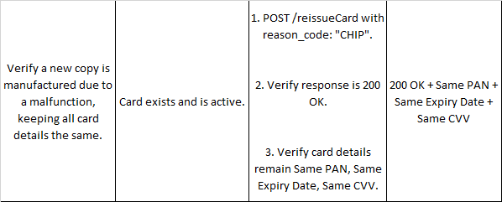
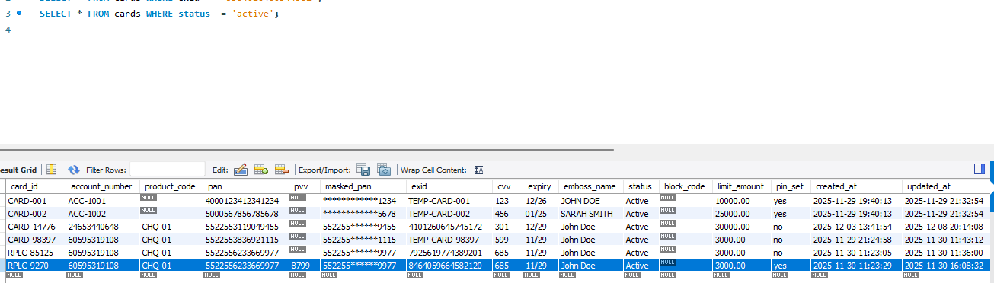

Request:
{
"external_id": "8464059664582120",
"reason_code": "CHIP_ERROR"
}

Response:
{
"success": true,
"message": "Card reissued/reprinted due to CHIP_ERROR. Same card details, new EXID used.",
"old_card_id": "RPLC-9270",
"old_card_status": "REPLACED",
"new_card_id": "RPLC-82843",
"new_pan": "552255******9977",
"new_expiry": "11/29",
"new_exid": "7857518873814338"
}

